LIS-600 Action Research Project – Using a Data Analytics Framework for Collections Management

Susan Buchan
Dept. of Information, Library, & Research Sciences, University of North Carolina - Greensboro
LIS 600: Foundations of Library and Information Science
Joanna DePolt, EdD
April 13, 2026

Abstract
For my Action Research Project, I have chosen to research developing a predictive analytics framework for use in public library collection development. To do this I set up a framework that utilizes Artificial Intelligence (AI) that can easily be used by library staff to analyze data and statistics for their library to streamline the collection development process. I will be using the AI tool Microsoft Copilot to extrapolate library data from existing data focusing on the Charlotte Mecklenburg Public Libraries for this research.
Introduction
Collection development is an important part of library management and often requires an enormous amount of time reviewing library statistics pertaining circulation, budget, costs, attendance, changes in demographics and patron needs with the goal of making informed decisions for maintaining a library collection. The goal of collection development is not only to support the current needs of library users but also to anticipate future trends and demands, ensuring that the collection remains relevant and valuable over time. (Ashikuzzaman, Md. 2025, July 30).
Librarians face a myriad of challenges developing and maintaining their collections. They face budget constraints, increasing costs and limited physical resources along with the need to ensure a diverse collection that includes digital books, databases, multimedia, periodicals along with traditional print materials. (Ashikuzzaman, Md. (2025b, July 31). The purpose of this research is to explore the use of predictive analytics and AI to help make the collection development process easier.

Review of Literature
During my research I found an excellent publication “Developing predictive analytics frameworks to optimize collection development in modern libraries” from the International Journal of Scientific Research Updates” which provided the following insight:
“Predictive analytics frameworks leverage historical usage data, user behavior patterns, and external trends in research and publishing to forecast resource demands. By employing machine learning algorithms and statistical models, libraries can identify emerging areas of interest, anticipate future needs, and proactively manage collections.” (IJSRU, E. 2024a, December 21)
Predictive analytics include providing insight into:
- historical data trends
- user behavior
- changes in library user population
These insights can allow a librarian to improve user satisfaction, improve cost efficiency and stay responsive to user needs.
From the Artificial Intelligence aspect of my research, I refer to an excellent research overview conducted by B. Jothimani, K. C. Anandraj and Dr. S. Aravind – “Artificial Intelligence in Collection Development and Management of Libraries: A Research Overview” (Anadraj, K.C. 2025, October). This research references articles, case studies and reports examining into the impacts of utilizing AI for Collection Development.
“One of the most transformative technologies impacting libraries today is Artificial Intelligence (AI), which is revolutionizing how libraries manage their collections and interact with patrons.” (Anadraj, K.C. 2025, October).
Also discussed is how predictive data analytics can help librarians make informed decisions and plan for future changes in library usage, optimize collections, reduce costs and provide excellent service to patrons. This research overview features a comparison of several platform utilized by many libraries that do include predictive analytics capabilities:
- Ex Libris Alma
- Yewno Discover
- Pro Quest Rialto
For my research I will not be delving into any of the existing library platforms as my goal is to take a more simplistic approach and explore utilizing technology that is more easily accessible to both librarians and students and to build a deeper understanding of utilizing predictive analytics frameworks in librarianship.
Research Methodology
To make informed decisions about their collections, public library staff often utilize data provided by outside resources such as one or all the following:
- The Library Research Service (LRS) which is part of the Colorado Department of Education, provides statistics on school, public, and academic libraries, and conducts studies on major library issues that are reported in the Fast Facts and Closer Look series.
- The Institute of Museum and Library Services (IMLS) which collects and maintains statistics from over 9,000 public libraries via the Federal State Cooperative System (FSCS).
- The Library of North Carolina which supports North Carolina by providing access to excellent libraries and promoting lifelong reading and learning.
For this research I have chosen to utilize statistics from the Library of North Carolina focusing on Charlotte Mecklenburg Public Libraries.
For this project, I utilized the Microsoft Copilot AI tool along with Microsoft Excel to organize the complex library statistics downloaded from the Library of North Carolina (referenced above) and applied a simple data analytics framework to simplify the data analysis process for collection management. The use of Generative AI within libraries is a growing trend, however still quite new and draws quite a bit of skepticism. My goal is to present my research in a way that can be understood by library staff and students and allow them to start exploring its use on their own.
To better understand the choice of Microsoft Copilot as the AI tool of choice for this research I found a recent article in SENTISIGHT.AI – “Why is Microsoft Copilot the Chosen AI Partner for Excel Spreadsheet?”. (Noreika, Alius, 2026, March 23). In this article Alius Noreika explains how Copilot is built directly into Excel, allows input instructions in plain English. Python is integrated into Microsoft Copilot which allows for advanced analytic functionality and outputs the Python code which is very useful allowing the code to be saved separately and tweaked and utilized later if desired.

Research
My goal is that with this research I will be able to break down the steps into understandable pieces that can serve as a learning tool to help those less experienced using Artificial Intelligence (AI) and predictive analytics get started. The following outlines my research procedures:
Step 1: Download Data
- North Carolina Public Library Statistics | Library of NC
- Choose 3 separate annual periods. 2021-2022, 2022-2023 & 2023-2024 were chosen for this project.
- Download the Excel Data Table for each of the 3 periods and save on your computer in a location of your choosing.
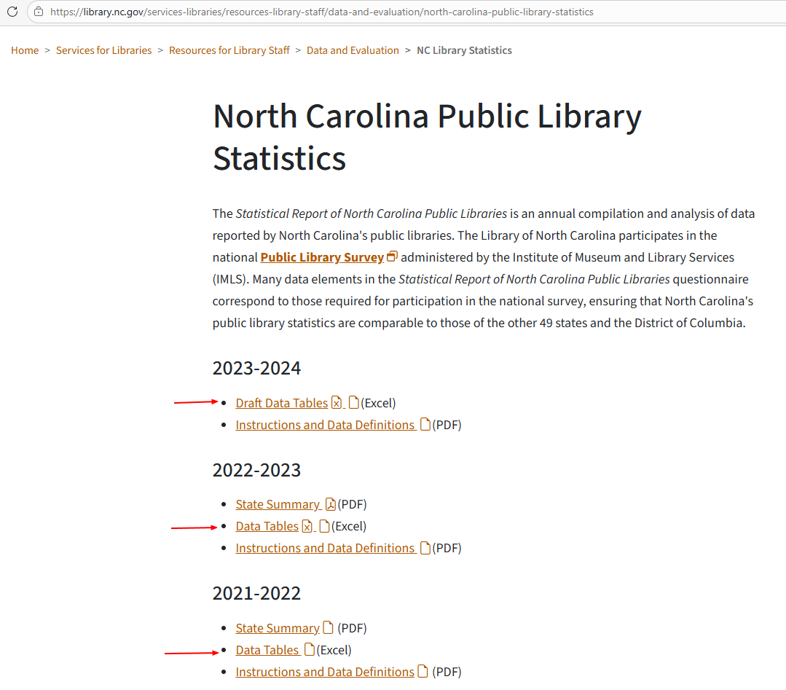
- The File will download as an Excel which can be saved at a location of your choosing.
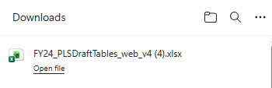

Below shows the files saved for 2022, 2023 & 2024.
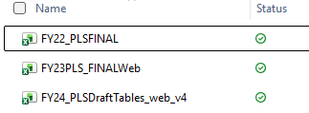
- The Excel Spreadsheet is comprised of multiple tabs including:
  - Summary
  - Library Profiles
  - Staff
  - Salaries
  - Income
  - Income%
  - Expenditures
  - Collections
  - Collection %
  - Circulation
  - Circulation %
  - Service Measures
  - Programming
  - Technology
  - Summer Reading
  - Partnerships

Step 2: Use Copilot to Summarize the spreadsheet data
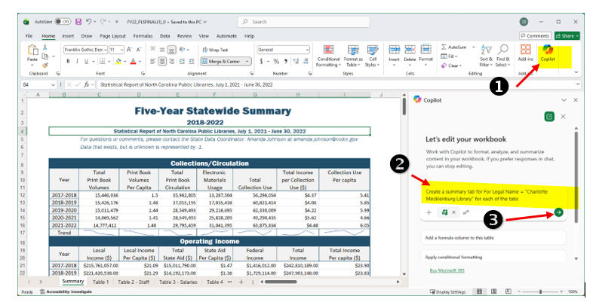

- Open one of the Microsoft Excel data files. I started with the file from 2022:
Open Copilot
Input the following prompt: Create a summary tab for For Legal Name = "Charlotte Mecklenburg Library" for each of the tabs
Click on the green “Send” button to submit the command.
- Copilot will create a new tab that summarizes the data from all the tabs on one new tab.
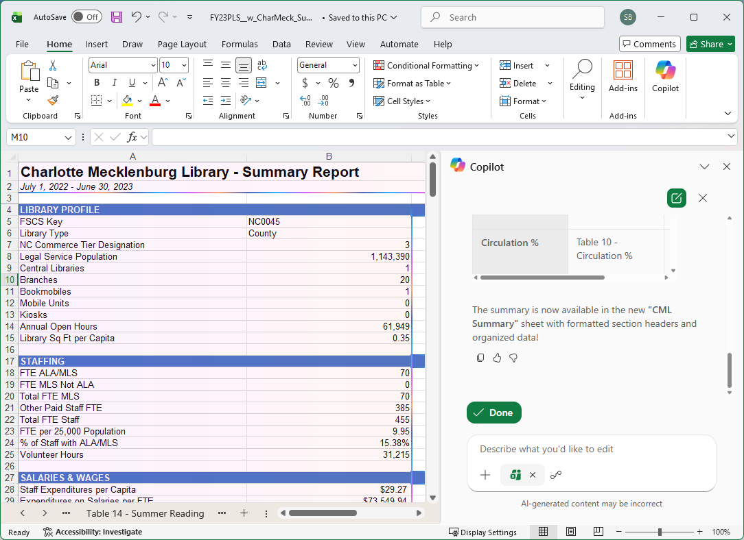

- Save the updated Excel Spreadsheet with the new tab.
- Open a blank Excel Workbook and copy and paste the summary data into a new spreadsheet and save.
- Save this new spreadsheet.
- Repeat for each annual data file that you wish to compare saving each file.
- Open a blank Excel Workbook and copy and paste the summary data from the first file (2022) into a new spreadsheet and save.
- Open CoPilot and copy and paste the data from the 2023 summary tab and paste into the prompt.
- Instruct Copilot to append the 2023 data to the 2022 summary data.

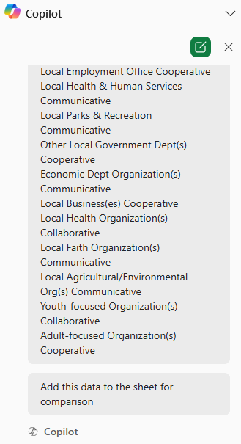

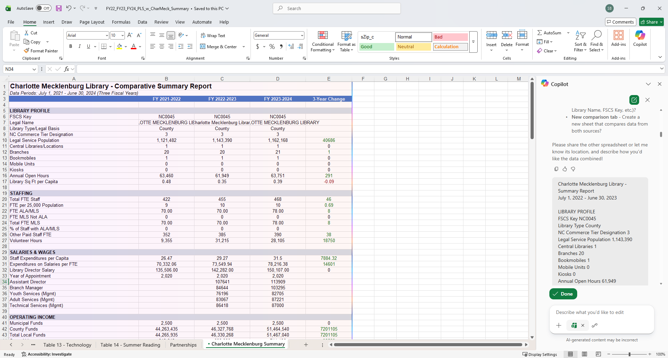

Step 3: Use Copilot to Create Predictive Analytics

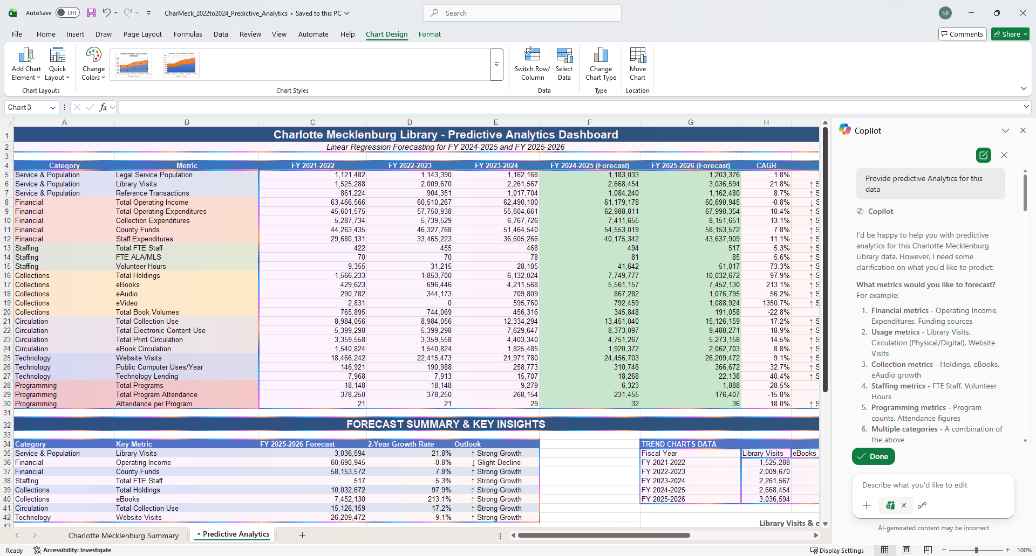
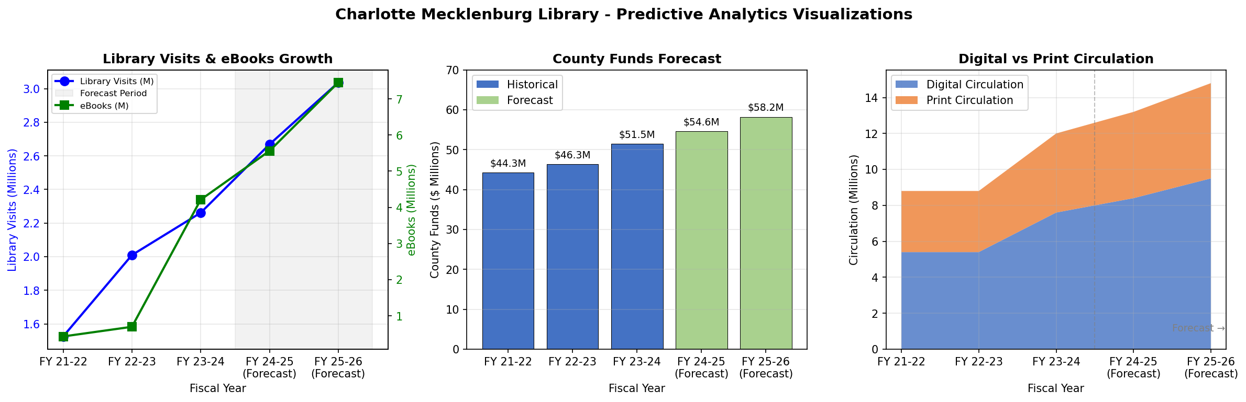
Complete analytics spreadsheet attached:

Step 4: Predictive Analytics Methodology & Reasoning
Lastly in the Copilot prompt, I asked Copilot to explain the reasoning for the predictive analytics which are provided below.

Predictive Analytics Methodology & Reasoning
1. Forecasting Method: Linear Regression
Why Linear Regression?
- Simplicity & Interpretability: Linear regression is a foundational statistical method that's easy to understand and explain to stakeholders
- Works with Limited Data: With only 3 years of historical data (FY 2021-2024), linear regression is appropriate—more complex models (like ARIMA or exponential smoothing) typically require more data points
- Trend Identification: It effectively captures the overall direction (upward/downward) of each metric
How It Works:
Forecast Value = Intercept + (Slope × Time Period)
- Uses scipy.stats.linregress() in Python (equivalent to Excel's FORECAST.LINEAR)
- Time periods: 1, 2, 3 (historical) → 4, 5 (forecast)

2. Growth Rate: Compound Annual Growth Rate (CAGR)
Why CAGR?
- Smooths Volatility: Unlike simple average growth, CAGR accounts for compounding effects
- Standard Business Metric: Widely used in finance and strategic planning for comparing growth rates across different metrics
Formula:
CAGR = (End Value / Start Value)^(1/n) - 1
Where n = 2 (the number of periods between FY 2021-2022 and FY 2023-2024)

3. Trend Classification Logic
Why Categorize Trends?
- Provides quick visual interpretation for decision-makers
- Highlights areas requiring attention (declining metrics) vs. successes (strong growth)
CAGR Range | Classification | Reasoning
> 5% | ↑ Strong Growth | Significantly outpacing typical inflation/population growth
0% to 5% | ↑ Growth | Positive but modest growth
-5% to 0% | ↓ Slight Decline | Minor decline, may be temporary
< -5% | ↓ Decline | Significant decline requiring attention

4. Metric Selection Rationale
26 metrics across 7 categories were selected to provide a holistic view:
Category | Reasoning
Service & Population | Measures community reach and demand
Financial | Tracks funding stability and spending efficiency
Staffing | Monitors human resource capacity
Collections | Tracks inventory and digital transformation
Circulation | Measures actual usage and engagement
Technology | Captures digital service adoption
Programming | Evaluates community programming effectiveness

5. Assumptions & Limitations
The methodology assumes:
- Trend Continuation: Historical patterns will continue into the future
- No External Shocks: No major events (pandemics, budget cuts, new branches) that would disrupt trends
- Linear Relationships: Growth/decline is constant over time (not exponential or logarithmic)
- Data Quality: The 3-year historical data is accurate and representative
Limitations Acknowledged:
- Only 3 data points limits statistical confidence (R² values may be low)
- Some metrics show irregular patterns (e.g., eVideo went from 2,831 → 0 → 595,760) which linear regression may not capture accurately
- External factors (economic conditions, policy changes) are not modeled

6. Why This Approach Was Chosen Over Alternatives
Alternative Method | Why Not Used
Moving Averages | Better for smoothing, not forecasting beyond current period
Exponential Smoothing | Requires more data points for reliable results
ARIMA/Time Series | Needs 20+ observations minimum
Machine Learning | Overkill for 3 data points; would overfit
Linear regression was the optimal choice given the data constraints while still providing actionable forecasts for strategic planning. (Microsoft Corporation, 2023).

Conclusion
This research was inspired by my many years working in technology and data analytics in the financial industry along with my first semester class LIS 610: Introduction to Collection Development and Management. The purpose of this research was to explore the possibility of using Copilot AI to perform the tedious task of manually reviewing extensive library statistic data. I feel I was able to test out a simple process of utilizing AI for these tasks with the goal of helping library staff and students learn some helpful uses of AI and dispel any misgivings of the utilizing this technology.
I am looking forward to expanding this research of utilizing AI within the library realm as I continue my journey within this program with the hope that upon graduating from this program, I will be able to apply my technology and data analytics experience in a career within a library which I feel will be an extremely rewarding experience.
Some ways that I would like to expand this research in the future include:
- Creating a training Power Point presentation that could be used for training library staff.
- Increase the complexity of the prompts to have AI pull the data directly from the web pages instead of downloading first.
- Set up Python Code that can be run to perform these tasks, setting up functionality that would allow librarians to specify specific data points to investigate.

References

- Anandraj, K. C. (2025, October 12). Artificial Intelligence in Collection Development and management in libraries. Proceedings of National Conference on Artificial Intelligence & Green Revolution: Transforming Library Management for Sustainable Future (GTNLIB-2024). https://www.academia.edu/126512563/Artificial_Intelligence_in_Collection_Development_and_Management_in_Libraries
- Ashikuzzaman, Md. (2025, July 30). What is library collection development? A comprehensive guide. Library & Information Science Education Network. https://www.lisedunetwork.com/collection-development-library/
- Ashikuzzaman, Md. (2025b, July 31). Challenges of library collection development. Library & Information Science Education Network. https://www.lisedunetwork.com/challenges-of-library-collection-development/
- IJSRU, E. (2024a, December 21). Developing predictive analytics frameworks to optimize collection development in modern libraries. International Journal of Scientific Research Updates. https://orionjournals.com/ijsru/content/developing-predictive-analytics-frameworks-optimize-collection-development-modern-libraries
- Microsoft Corporation. (2023). Microsoft Copilot (Version 1.0) [Computer software]. Microsoft. https://www.microsoft.com
- Noreika, Alius (2026, March 23). Why Microsoft Copilot is the top AI for Excel. SentiSight.ai. https://www.sentisight.ai/microsoft-copilot-ai-partner-excel-spreadsheets/
- North Carolina Public Library Statistics. North Carolina Public Library Statistics | Library of NC. (n.d.). https://library.nc.gov/services-libraries/resources-library-staff/data-and-evaluation/north-carolina-public-library-statistics
- Wicen, S., & Bahlenhorst, A. (2026, April 2). Welcome to library research service. Library Research Service. https://www.lrs.org/
- Public libraries survey (PLS). Institute of Museum and Library Services. (n.d.). https://www.imls.gov/research-evaluation/surveys/public-libraries-survey-pls

